LED Integrated Testing System test report

test item: | LED spectrum analyse
equipment: | Led test system
设备厂商获得证书： | 国家半导体工程研发及产业联盟证书，中国光学光电子行业协会光电器件分会证书，高新技术企业证书
 | Mode:MB 030 NRA 20061030 6000K | Manufacturer:
Test Identifier | Temperature:25℃ | Humidity:60%
Test Identifier | Conner: | Date:2017.01
 | Organ:
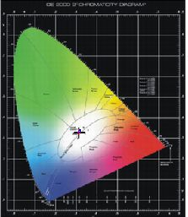
curve of spectrum power distributing
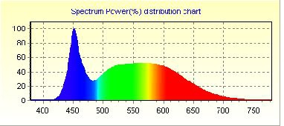

Spectrum |  |  | Electrical
λ(Peak): | 451.5 | nm | I(test): | 260.000 mA
λ(Main): | 489.7 | nm | Vf: | 220.100 V
λ(Centroid): | 0.0 nm |  | φv: | 2388.00 lm
λ(Center): | 0.0 nm |  | Efficiency: | 78.812 lm/w
BandWidth: | 24.7 | nm | P: | 30.3 W
ColorTemp: | 6290 | K | PFC: | 0.528
CIE(x,y): | 0.3110, 0.3299 |  | Ra1:82.2 | Ra2:89.0 | Ra3:93.5
CIE(u,v): | 0.1963, 0.3124 |  | Ra4:84.4 | Ra5:83.6 | Ra6:84.7
Ra: | 84.3 |  | Ra7:87.2 | Ra8:69.7 | Ra9:12.4
Purity: | 0.078 |  | Ra10:73.7 | Ra11:86.3 | Ra12:57.2
Light Power: | 6381.8966 mw |  | Ra13:83.8 | Ra14:96.7 | Ra15:76.9

Remark:

page 1 of 1 2016-11-10 16:32:14

